Lesson 4 Demo 3: Create a Host Network

This section will guide you to:

* Create a standalone container that binds directly to the Docker host’s network
* Inspect the container to check the network mode

**Step 1:** Create and start a container as a detached process and use the *host* networking driver

*sudo docker run --rm -d --network host --name nginx_container1 nginx*



**Note:** The host networking driver works only on Linux hosts and is not supported on Docker Desktop for Mac or Windows server.

**Step 2:** Access the *nginx* container by browsing [*http://localhost:80/*](http://localhost:80/)

* Click on the master tab and click on Desktop to open the Ubuntu desktop window

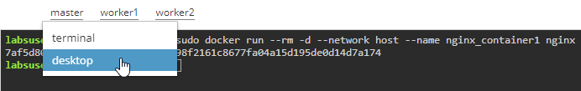

* Open the browser and navigate to [*http://localhost:80/*](http://localhost:80/)

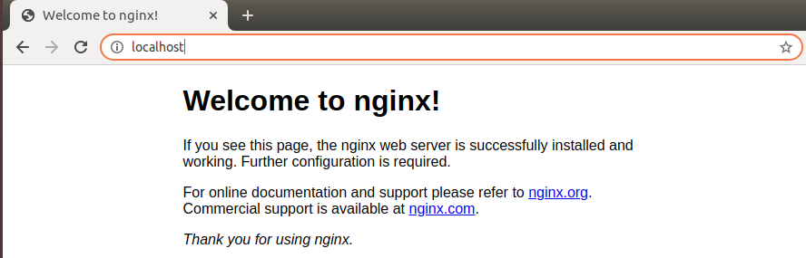

**Note:** Navigate back to the master tab with the Ubuntu Terminal

**Step 3:** Inspect the container to check the **NetworkMode** under the **HostConfig**

*sudo docker container inspect nginx_container1*

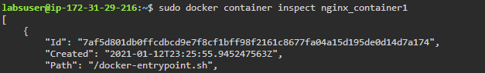

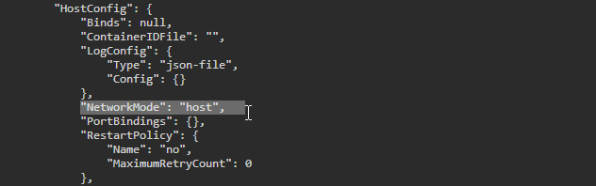

**Step 4:** Verify which process is bound to *port 80* using the *netstat* command

*sudo netstat -tulpn | grep :80*

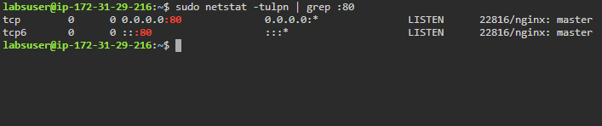

**Step 5:** Examine all the network interfaces, and verify that a new network has not been created

*ip addr show*

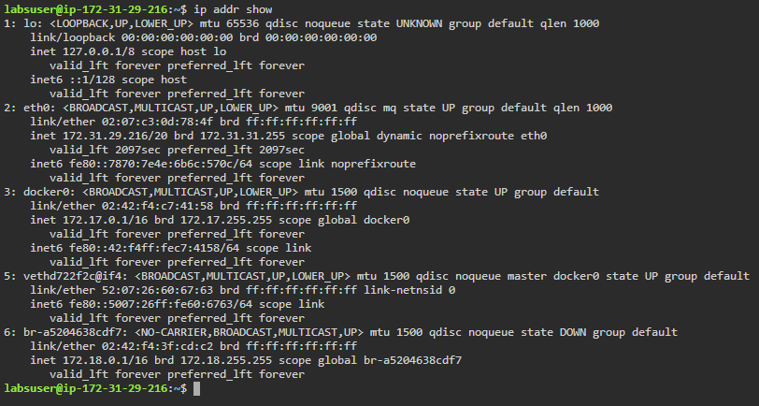

**Step 6:** Stop the container using the following command:

*sudo docker container stop nginx_container1*

